Group 70 A2 Review

# Do images filter correctly when clicking names?

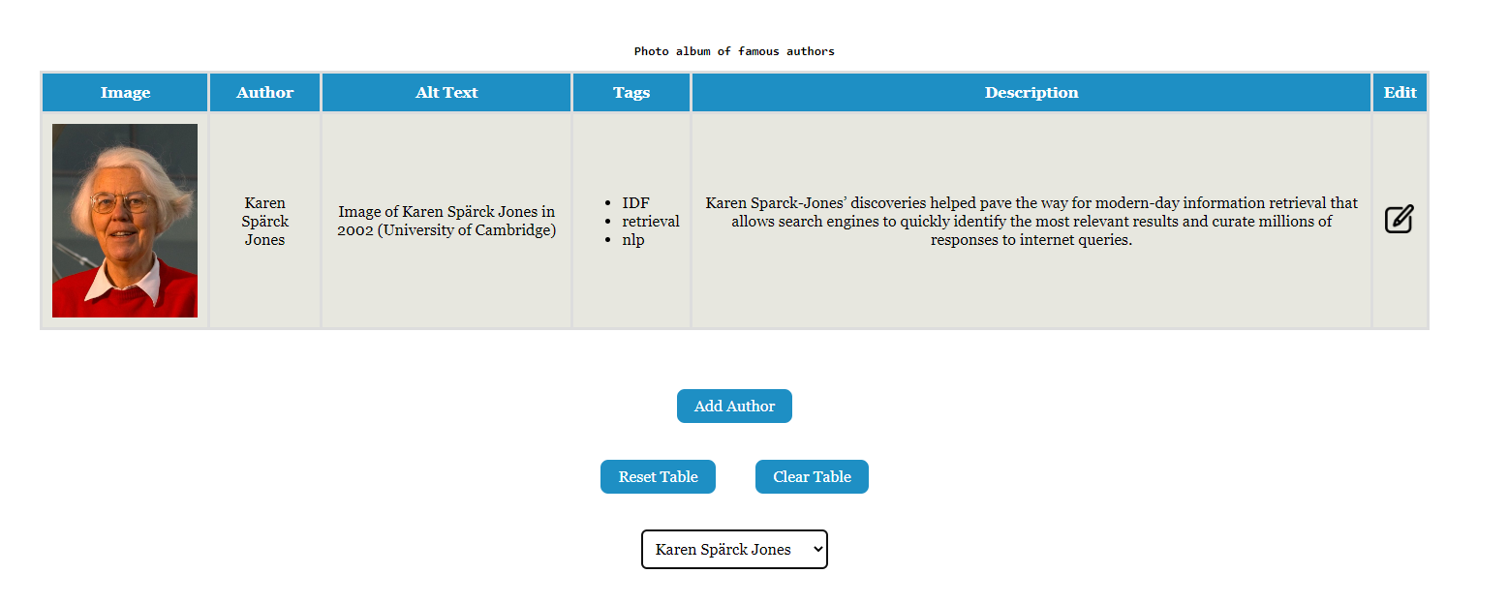

When Karen Spärck Jones is selected, she is the only one that appears in the table. In addition, the table is refreshed - this is the intended functionality.

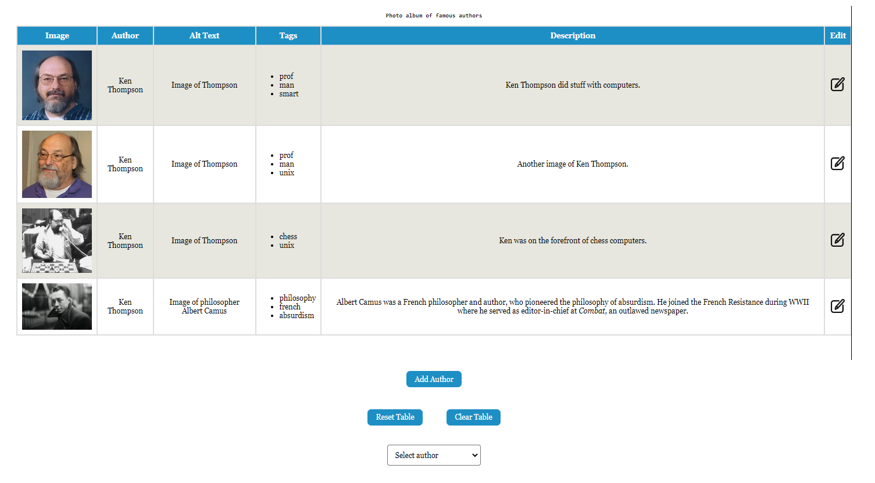

When Ken Thompson is selected, all of the entries with the author name of Ken Thompson, including one that was added by us, works. The table does not refresh - this is the desired behaviour.

# What happens when you "unclick" a name?

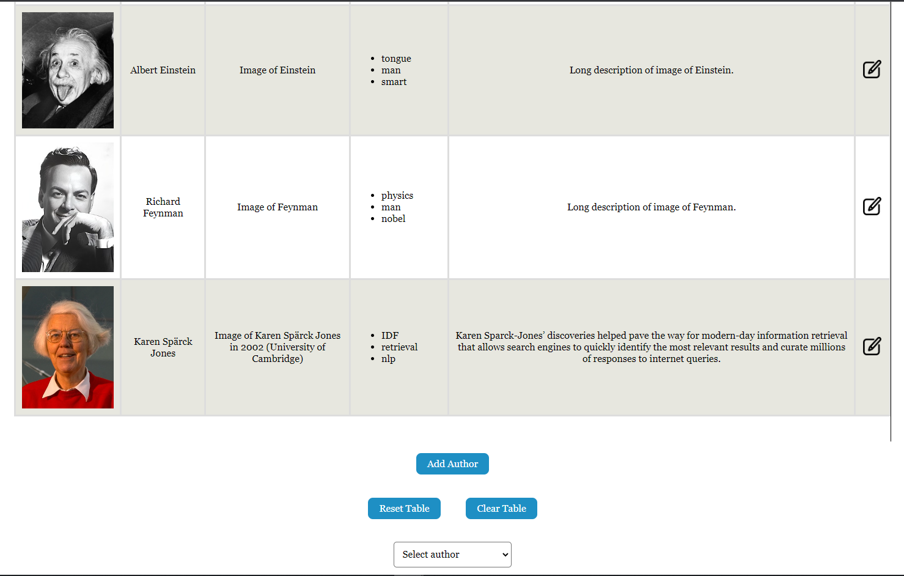

A screenshot is too small to convey the idea that all of the items are shown when “Select author” is chosen, however, the feature works as intended. Unclicking in the filter correctly shows all the authors in the database, however when pressing all authors the database will reset, so any inputs made beforehand are deleted. This might have been intended but could also be an unintended consequence of reloading the table.

# Has the bonus been implemented? If so, does the bonus work correctly, also when clicking names etc.?

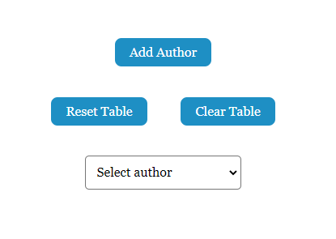

N/A - Bonus not implemented

# How does their modal form work?

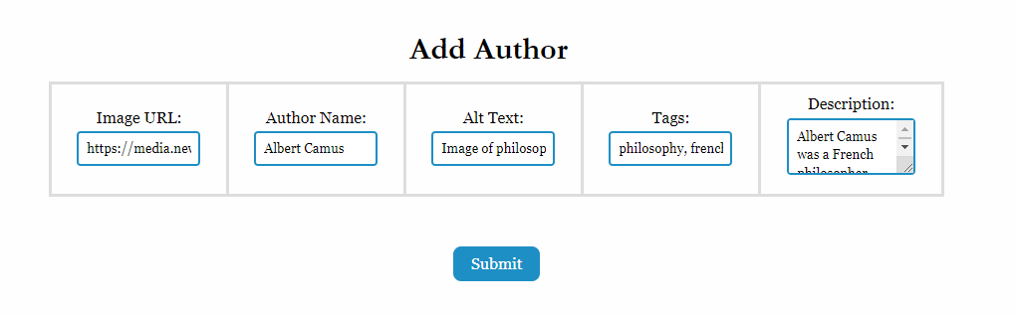

The modal correctly opens an overlay with the necessary inputs to create or modify a row. The modal to create a new author is also filled out at the start, this might have been some left over sample data to test the modal. The modal to create a new row also does not reset the data inside when it is submitted, which would have been nice to see implemented.

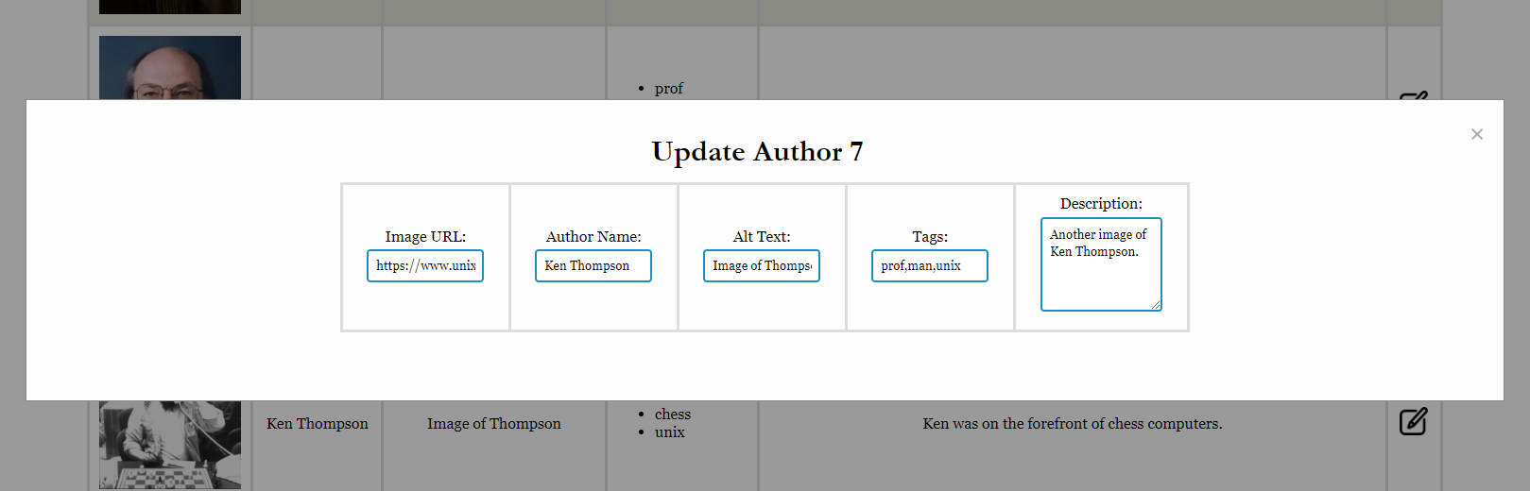

When modifying a row the modal is successfully filled with the correct data, allowing for modifications to be made easily.

# Can you update, reset, and upload new images?

## Updating

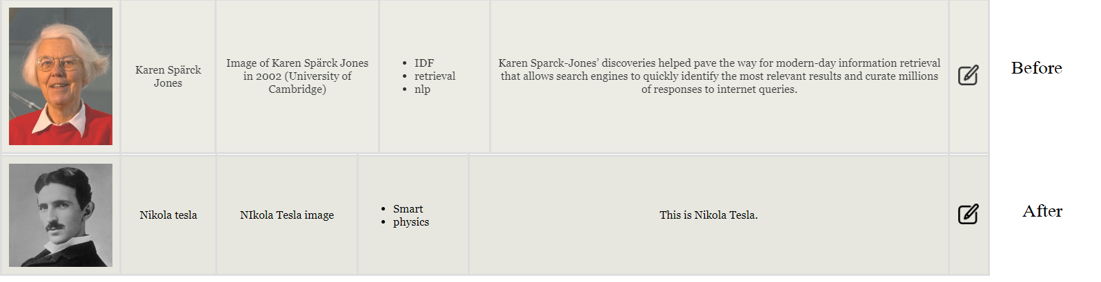

Updating works as intended - all of the fields are changed, and the tags (entered as “Smart, physics” are separated correctly into two separate bullet points. However, valid error validation is missing - if one of the fields is not entered and the form is submitted, the modal disappears & the data is not altered.

## Resetting

Before:

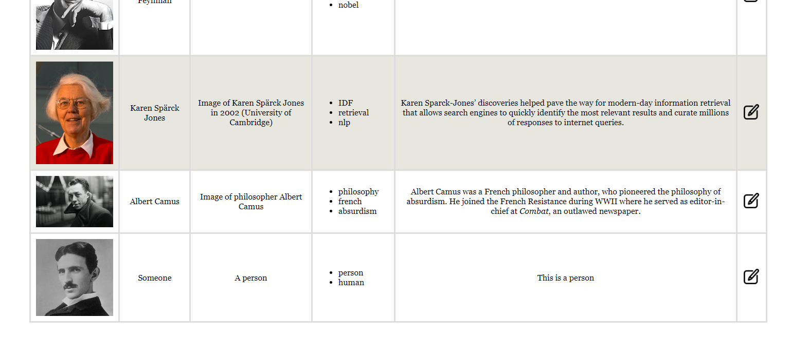

This is the end of the form before resetting.

After:

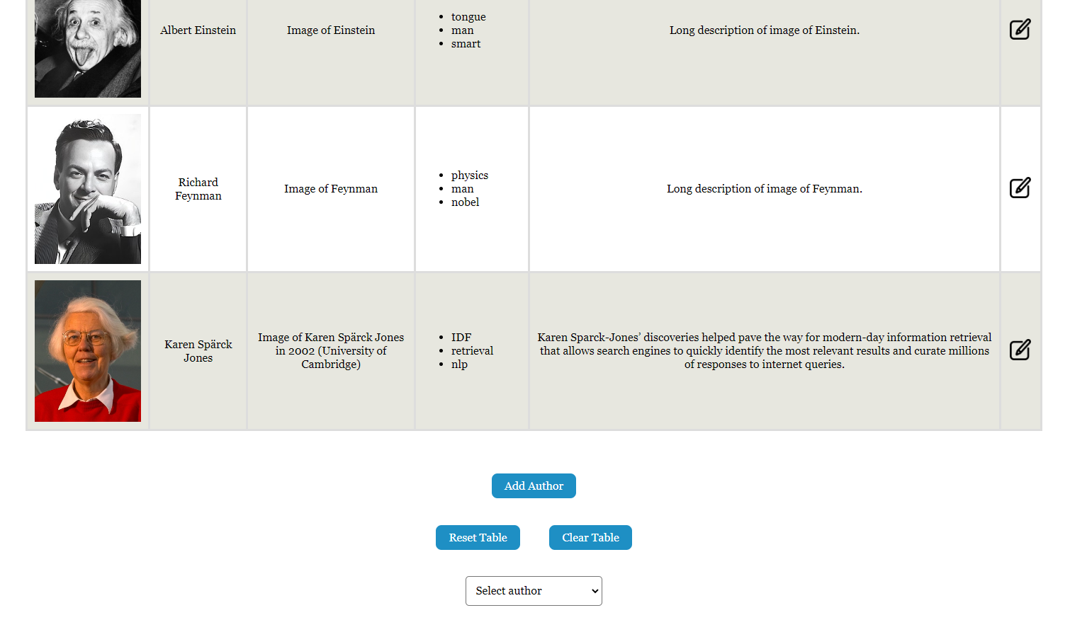

This is the form after resetting. All of the entries that were added manually are cleared, and the database is cleared appropriately too. This feature works as intended.

## New Images



Adding a row with a new image works as intended, both in terms of the dynamic addition with DOM and the entry into the database. However, the form is not cleared after a submission - this would have been nice to see.

# Is their gallery content properly dynamic, e.g. is the content data loaded from the https://wt.ops.labs.vu.nl/api23/ server?

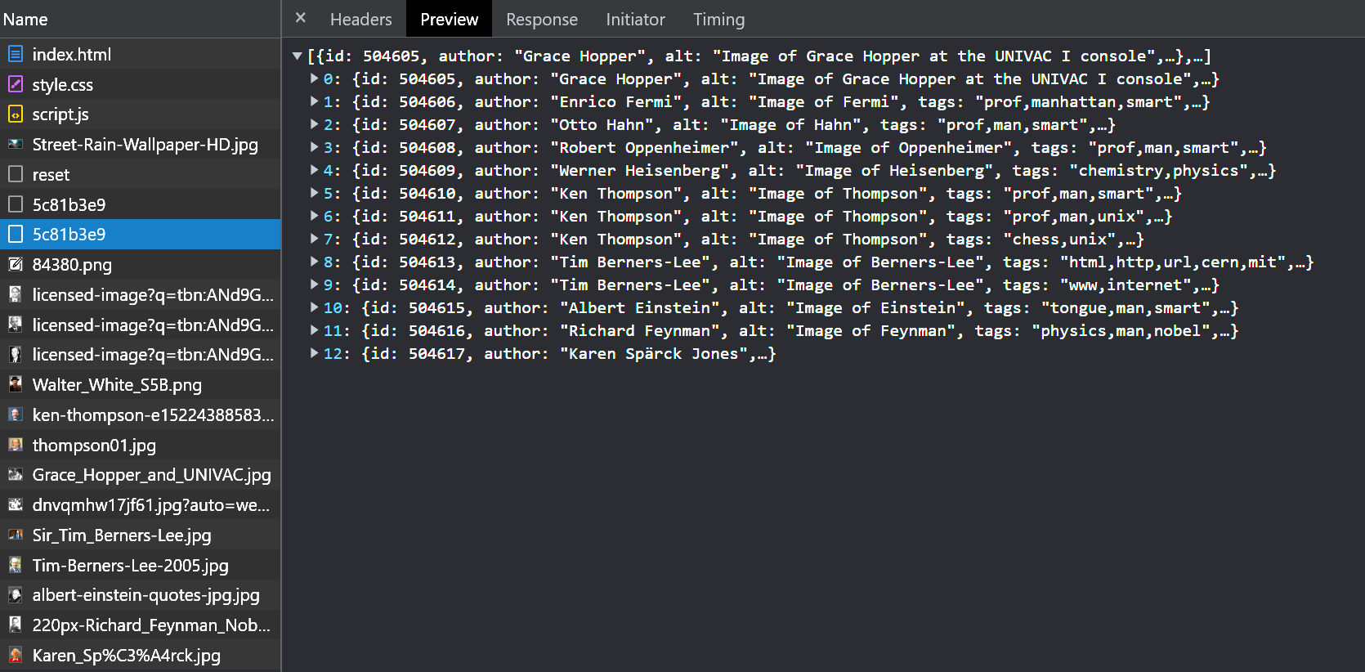

All the content is loaded from the API, however when the page reloads it automatically sends a reset request before loading the content, this causes all the created data to disappear. The code correctly uses async await to make sure all content is loaded successfully.

# Does submitting new images work on a single page, and does the new image show up without a reload?

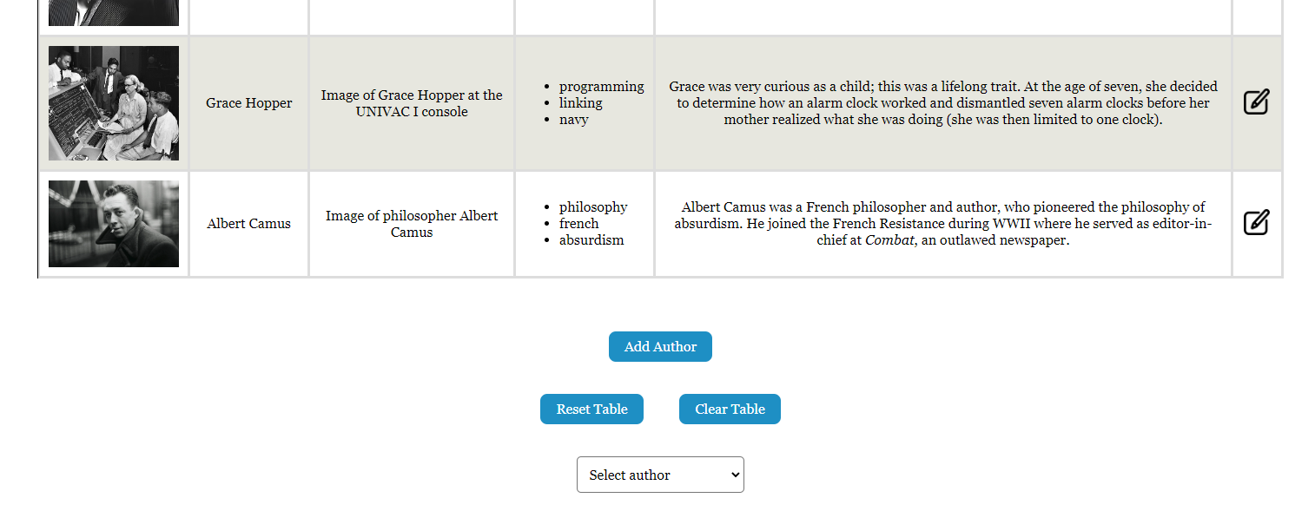

Submitting a new gallery entry works on a single page, as required. Right after submission, the image appears on the page without the page refreshing - this is the desired functionality.

# Actionable Feedback

We would recommend removing the reset when loading the table as this makes it easier to use the website with multiple users. In addition, we would also recommend removing the reset when filtering authors as this causes the user to lose all his changes when filtering.

In addition, please include validation in the forms to create and update authors. Users may think that certain columns are not mandatory when creating/updating authors, however, this is not the case. A user has no way to know this, and they may be left confused when the form appears to have accepted their input, yet not updated appropriately. In addition, the lack of validation leads to weird behaviour on your website, such as the last entry being duplicated rather than a row with the entered information being created if some piece of information from a submission is entered - proper form validation would fix this.

# What we learned

The way that a modal form is generated to edit each row is a very nice functionality and implemented in a way that we have not thought about before. The incrementing IDs given to each row is a big part of this implementation and is done in a way that circumvents the fact that the API did not return an ID upon the creation of a new row - this eliminates the need for unnecessary code.